

{{DATE}}

**{{CLIENT_NAME}}**

**{{ADDRESS}}**

**ATTENTION: {{CONTACT_PERSON}}**

Dear Sir/Madam,  
  
We take special pleasure in submitting our firm quotation for the KYOCERA DIGITAL COPIER ECOSYS MA6000ifx as follows:

**BLACK ‘n WHITE COPY & PRINT, COLORED SCAN**

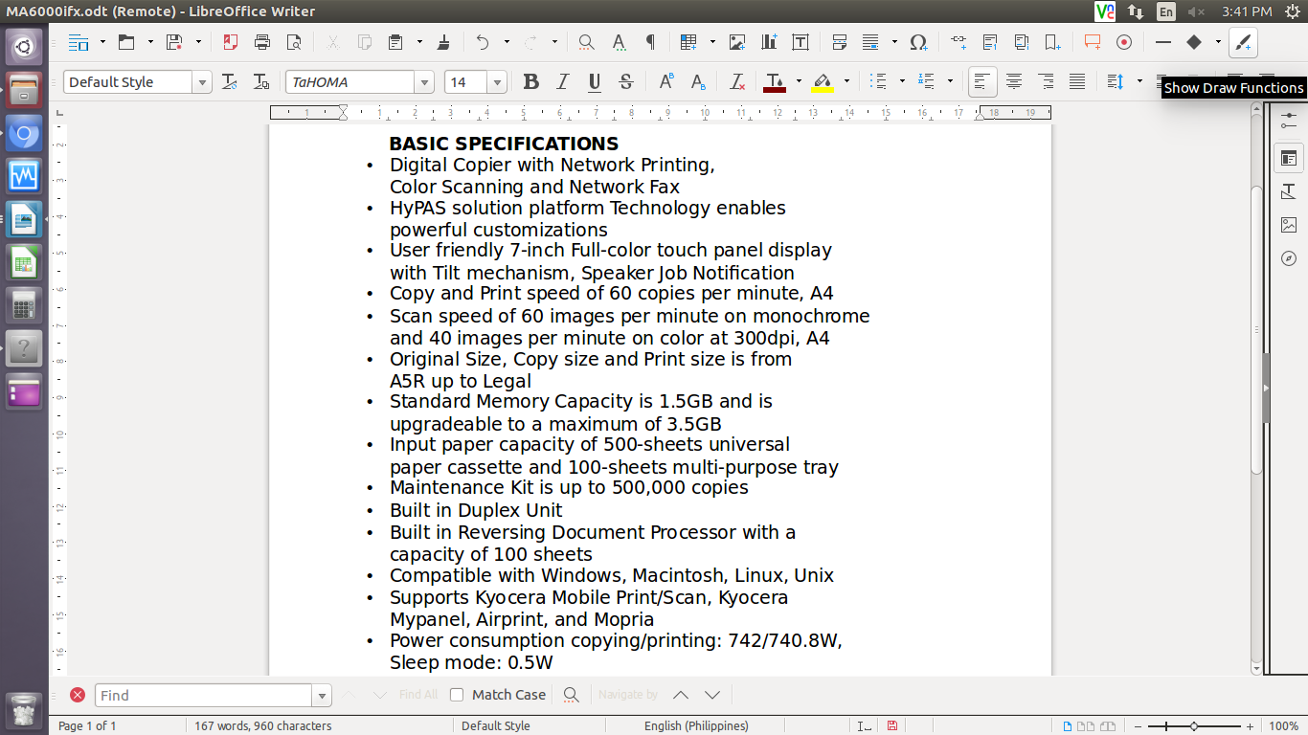

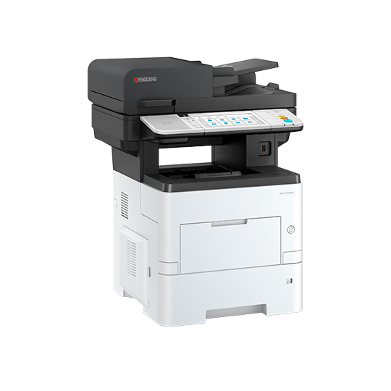

* **PRICE OF MACHINE & ACCESSORIES:**

|  |  |  |
| --- | --- | --- |
| 1 unit of KYOCERA DIGITAL COPIER ECOSYS MA6000ifx | ₱ | 273,600.00 |

**PROMO PRICE**

MACHINE ORIGINAL PRICE: ₱ 273,600.00

LESS PROMO DISCOUNT ₱ 63,600.00

**TOTAL DISCOUNTED AMOUNT ₱ 210,000.00 (LESS 10% IF CASH = ₱ 189,000.00)**

₱ 17,500/MO. FOR 12 MOS. (CREDIT CARD)

**OPTIONAL/ACCESSORIES (NOT INCLUDED IN THE MACHINE PRICE)**

WIFI/WIRELESS LAN ₱ 8,000.00

ADD’L 3 YEARS SERVICE WARRANTY EXT ₱ 9,750.00 (TOTAL 5 YEARS)

STEEL TABLE/CABINET/PEDESTAL ₱ 6,700.00

* **PRICE OF CONSUMABLES (FOR REFERENCE ONLY)**

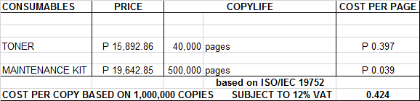

**Terms of Payment:** CASH  
  
**VALIDITY:** Prices are subject to change without prior notice. Please confirm with us before the finalization of the order.  
  
**WARRANTY:**   
  
KYOCERA DIGITAL COPIER ECOSYS MA6000ifx is guaranteed on spare parts replacement FREE OF CHARGE for TWO (2) years, or up to 500,000 copies/print/scan/fax, whichever comes first.  
  
Warranty for accessories and options is ONE (1) year from the date of delivery.  
  
We also assure you of prompt service whenever you need assistance. Repair service is FREE for TWO (2) years.

Installation and Training of Personnel: Our expert service engineers install all our machines, and they are happy to provide free training to interested personnel on the detailed mechanics of the machine.

We are looking forward to hearing from you soon. For any questions or concerns, please feel free to call us at 09176240820 (Viber-ready).  
  
  
Very truly yours, Conforme:

**JAYPEE V. SONIEL __________________________________**  
SENIOR ACCOUNT EXECUTIVE II

09176240820 (Viber Ready)